Project Identification

Project: | Pay-A-Bit
Prepared By: | Darshan Shah
Document Version: | 1.0
Published Date: | 2/10/18

Contributors
The following individuals contributed to this document.
Name | Title
Neel Patel | Team Member
Jaydeep Khambholja | Team Member
Akaash Arora | Team Member

Distribution
This document is distributed to all the following people.
Name | Title
Anjana Shah | Instructor

Referenced Documents
This document refers to the following materials
Version number | Title | Author | Date | Source / Location

Revision History

Version Number | Revision Date | Summary of Changes | Modified by
[Note: It is recommended that drafts be numbered 0.1 to 0.9, and that the first approved version be numbered 1.0. Thereafter, new version numbers will depend upon changes: 1.01, 1.1, etc for minor updates, 2.0, 3.0 etc for major changes.]

TABLE OF CONTENTS
1. Business Context Diagram 3
2. REquirements Scope Statements 4
3. High Level Business Requirements (HLR) Traceability 4
4. High Level Business Requirements Sign-Off 5

- Business Context Diagram
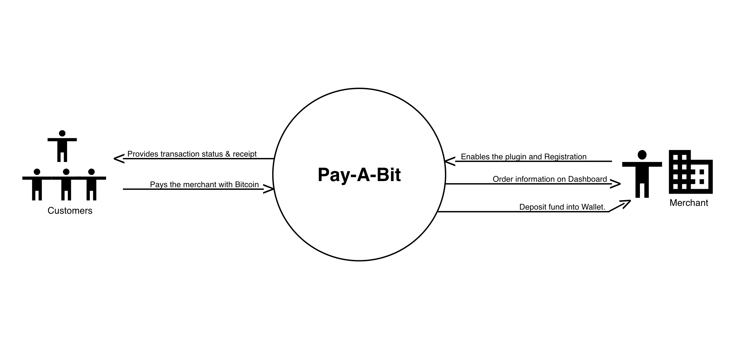

Requirement Scope Area | Description
Pay-A-Bit WordPress Plugin | The plugin itself is responsible for processing the payment and depositing the funds into merchant’s wallet.

External Entity | Description
Customers | Customer or person who will be paying with Bitcoin on a website and will be getting a confirmation receipt after the transaction.
Merchants | A website owner or a developer who would be implementing the plugin on his/her website that will accept Bitcoin and provide the transaction history on a dashboard.

Information Flows | Description
Customer Data | Information such as the cart total, email address that will be used while generating the receipt and processing the payment
Merchant | Registration information like wallet address, preferences that will used as the core data for the plugin installation and depositing the funds to the wallet.
- Requirements Scope Statements
HLR# | Description | Priority  (H, M, L)
 | Provide ability to accept Bitcoin as a payment method on website | H
 | Merchant should be able to view past transaction statuses. | H
 | Customer would be provided with a transaction receipt | M

- High Level Business Requirements Sign-Off
The undersigned acknowledge their agreement with the contents of Version 1.0 of the High-Level Requirements document for Pay-A-Bit.

Following approval of this document, requirements changes will be governed by the project’s change management process, including impact analysis and appropriate reviews and approvals, under the general control of the Project Plan and according to company policy. Approved Change Request Documents, if present, will be attached to this Requirements Document as updates.

Name | Project Role and  Functional Area | Date Signed
Neel Patel | Development & Scrum Master | 2/10/2018

* Note: physical signatures are not required. Email approvals are acceptable and should be appended to project documents.

